(E8.4) The frequency response for a process of the form

is shown in Figure E8.4. Determine K and a by examining the frequency response curves.

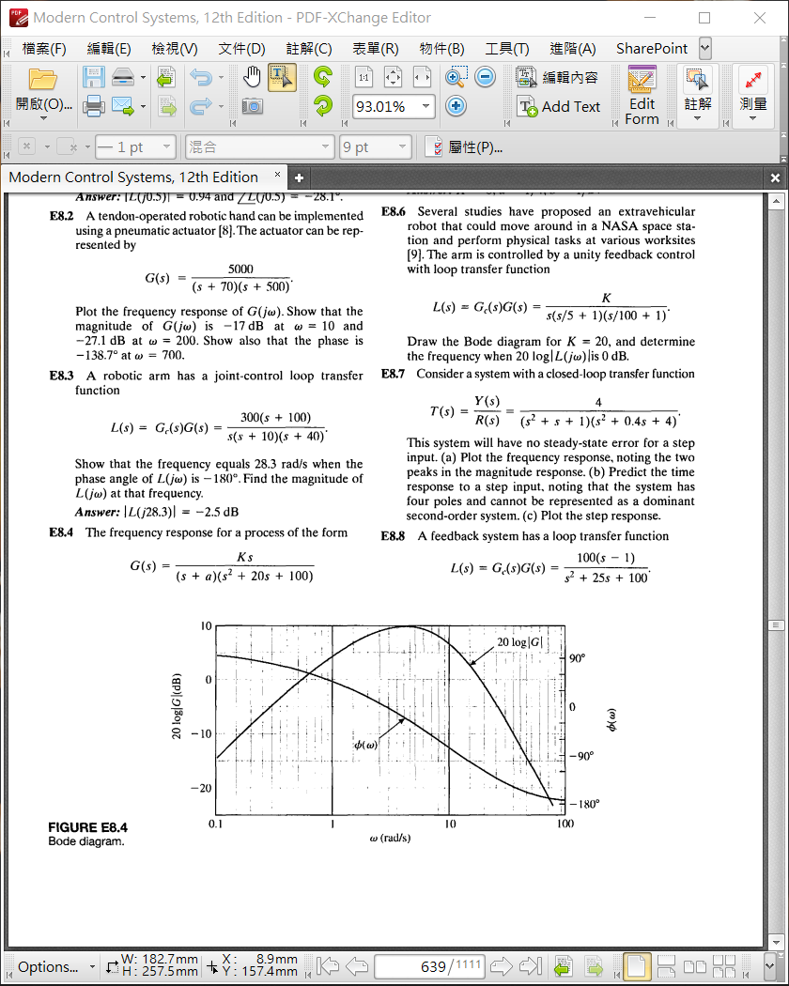

Ans.

* Note that at , then we can get
* From the magnitude relationship we determine that .

(E8.5) The magnitude plot of a transfer function

is shown in Figure E8.5. Determine K, a, and b from the plot.

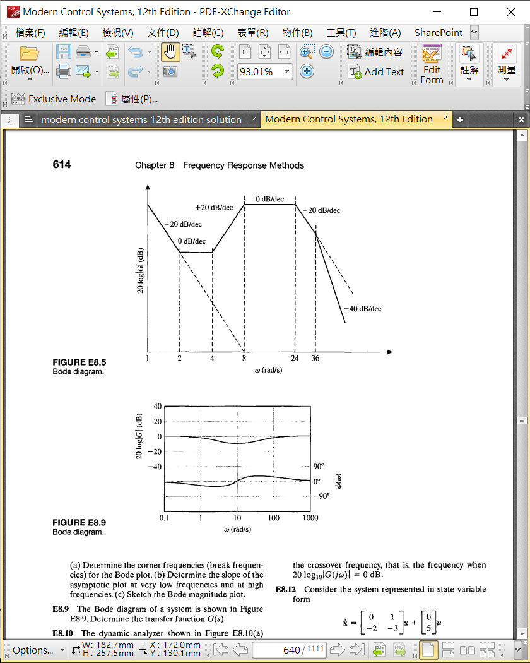

Ans.

* Pole: 0, 8, 24, 36; Zero: 2, 4
* at

(E8.6) Several studies have proposed an extravehicular robot that could move around in a NASA space station and perform physical tasks at various worksites [9]. The arm is controlled by a unity feedback control with loop transfer function

Draw the Bode diagram for K=10 and determine the frequency whenis 0 dB.

Ans.

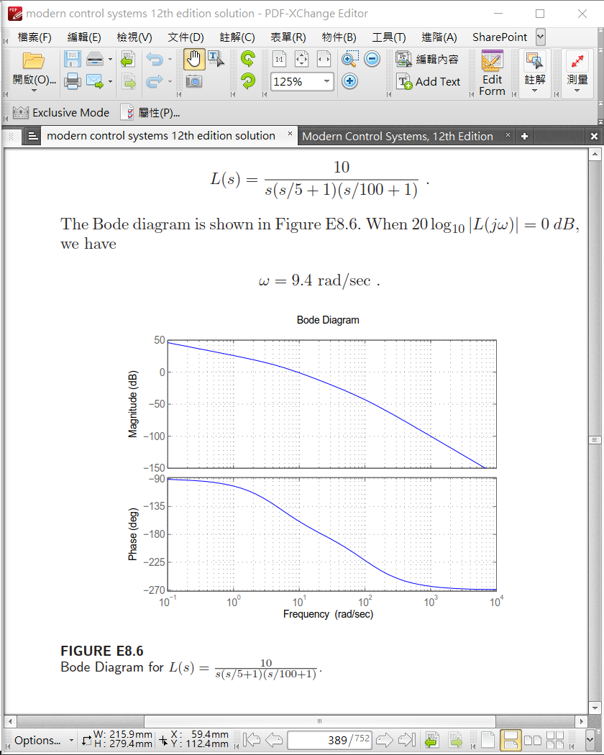

(E8.8) A feedback system has a loop transfer function

1. Determine the corner frequencies (break frequencies) for the Bode plot
2. Determine the slope of the asymptotic plot at very low frequencies and at high frequencies
3. Sketch the Bode magnitude plot.

Ans.

1. Corner Frequencies:
2. The slope of the asymptotic plot at low frequencies is 0 dB/dec.

And at high frequencies the slope of the asymptotic plot is -20 dB/dec.

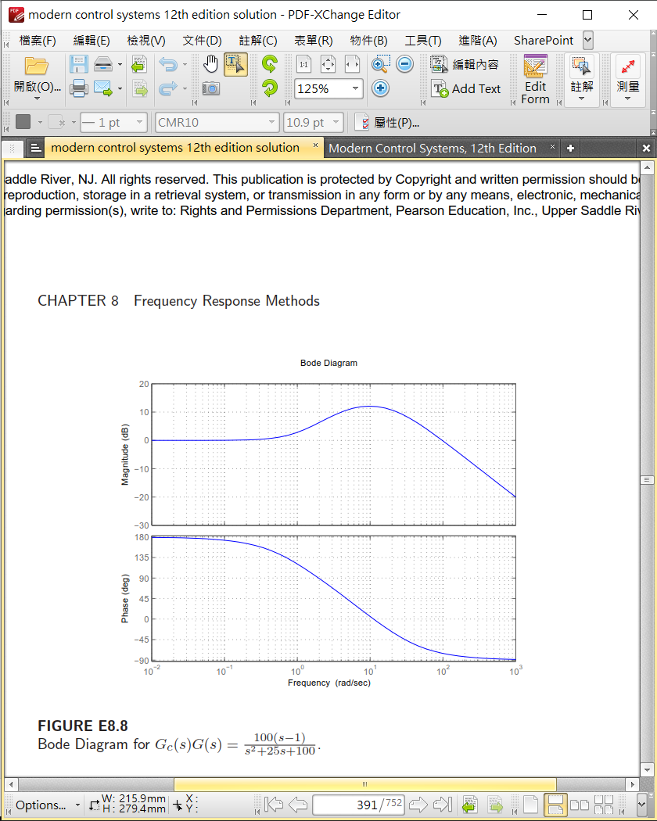

(P8.6) The asymptotic log-magnitude curves for two transfer functions are given in Figure P8.6. Sketch the corresponding asymptotic phase shift curves for each system. Determine the transfer function for each system. Assume that the systems have minimum phase transfer functions.

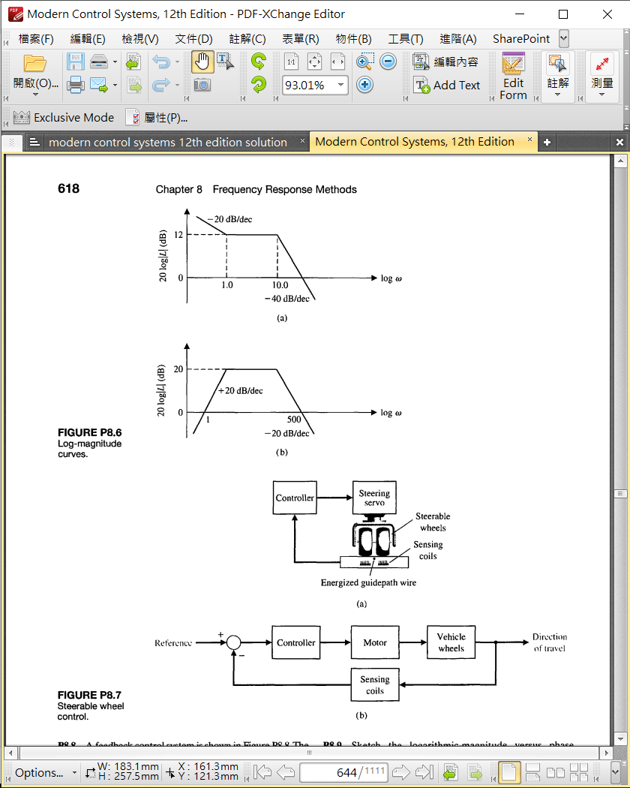

Ans.

